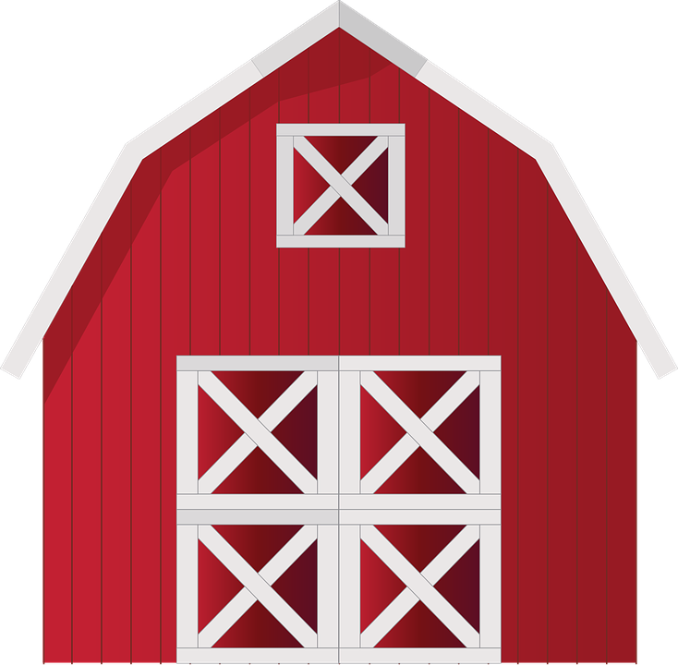

**Down on the farm**

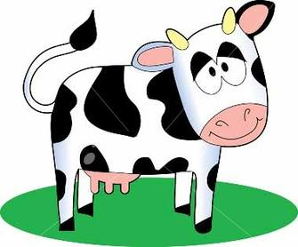 

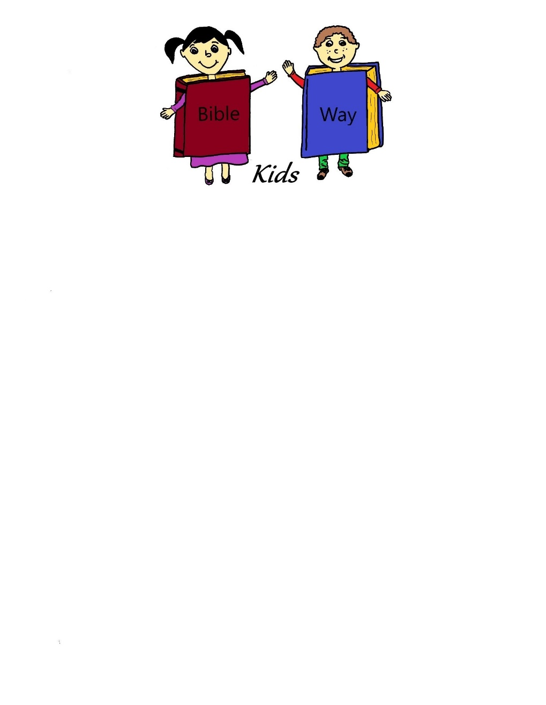

A Bible Way Kids curriculum compiled by:  
Heritage Family Church  
3840 N. Seneca, Wichita, KS 67204  
316-942-6652

**Down on the Farm**

**Table of Contents**

**Lesson One:** The Sower and the Seed

**Lesson Two:** The Cow that Witnessed a Special Birth

**Lesson Three:** There’s a Snake in the Garden

**Lesson Four:** The Talking Donkey

**Lesson Five:** The Hen and Her Chicks

**Lesson Six:** Money in the Mouth? Smells Fishy!

**Lesson Seven:** The Pig Pen

**Lesson Eight:** Cock-A-Doodle-Do! The Rooster Crowed

**Lesson Nine:** The Lost Sheep

**Lesson Ten:** The White Horse- Jesus Returns!

**Lesson Eleven:** Party and Review

**Down on the Farm**

This is a favorite series. A farm. Animals. Fun. How can a child resist? The Bible is full of animals and this series is about ten of them and the part they played in the lives of the people around them.

The room décor is a farm. Every farm has a barn and a cornfield and a tractor and a chicken coop and a pig pen and scarecrows and lots of other cool things. Donkeys, horses, even snakes…

Along with the above named items we had an apple orchard and a farmer and his wife.

The costumes for the women were aprons, denim, bonnets, etc…., the men would wear denim jeans or bib overalls, straw hats and bandanas.

The fun is in making the animals come alive to the children.

Have fun on the Farm!!

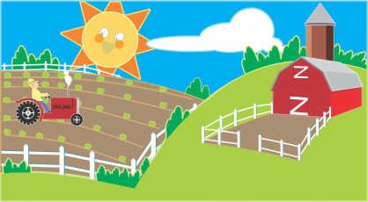

**Down on the Farm**

**Lesson One: The Sower and the Seed**

**Lesson at a Glance**

**Pre-session:** Dry pumpkin seeds, liquid watercolors, cardstock paper, liquid glue, small plastic bowls for glue, thin paint brushes, sorting tray for seeds (I grabbed mine from a local Dollar Tree)

**Song and Offering:** Offering plate or tin

**Memory Verse:** small shoe box (decorated) and prize candy to go inside

**Lesson:** Picture Cards from Resources, a deck of cards, cloth grocery or shopping bag, farmers hat, bandana, and Dum Dum suckers

**Craft:** Small Styrofoam cups, potting soil, flower seeds, stickers, permanent markers

**Extended Time Game:** Chairs

**Down on the Farm**

**Lesson One: The Sower and the Seed**

**Scripture Reference: Matthew 13:1-23**

**Memory Verse: Acts 2:38** Then Peter said unto them, Repent and be baptized every one of you in the name of Jesus Christ for the remission of sins and ye shall receive the gift of the Holy Ghost.

**Welcome:** Greet each child with a big smile and a “Howdy-Do!”

**Pre-session:** Pumpkin Seed Names:Dye the pumpkin seeds a day or so before the activity. I placed some seeds in a plastic bag, added a few squirts of liquid watercolors, and then shook up the bag. Once the seeds were colored, I spread them on a paper towel to dry overnight.

Give each child a cardstock paper and write their name in large letters on the page. Let them trace their name with the paint brush dipped in glue and glue different colored pumpkin seeds to create their names.

**Song and Offering:** “Read Your Bible, Pray Every day” It’s the best way to make sure that Jesus stays our friend.

**Craft:** Planters: Give each child a small Styrofoam cup to decorate with stickers and write their name. After their name is on the cup, place enough potting soil until the cup is 3/4ths full. Give each child some flower seeds to plant in their cups. Show them how to read a seed packet to find information as to how long it takes for the seed to germinate and how much water and sun it will need to grow. Use water to dampen the soil after planting.

**Memory Verse:** Have the children sit in a circle. Use a small shoe box and decorate it up as a gift but with the ability to open the lid. Have the children pass the box around the circle saying one word at a time. The person who says “38” will pass the box to the next person and that person will open the box and get one candy. They will then close the box and say “Then” and the game will start again. Go around the circle as time allows or until every child has a candy.

**Lesson:** *(Choose someone to be the sower. Have them put on bandana, the hat, and the bag over their shoulder.)* This is our farmer. The bible talks about the farmer sowing or planting the seed. When our farmer sows the “seed” today, hang onto it until the end of the story. *(Encourage the farmer to sow the seeds where everyone will have at least one.)* Great job, Farmer. You know how to sow those seeds! Notice that when the Farmer sowed the seeds- they went everywhere!

*(Read the story from the bible then tell the story in your own words.)* The seeds that Jesus was referring to were the word of God. When the sower was out sowing the seeds, some of the seed fell on the way side or the path that everyone walked on so the ground was hard and before the seed could take root, the birds came and ate the seed. *(Choose a volunteer to hold Picture Card #1.)* Jesus said that when the word is preached and you don’t understand what it means, the devil will pluck that word right out of your heart before it takes root.

The seed also fell on some rocky soil. When the seed tried to grow there was not enough dirt or water available and when the sun came up, the seed was burnt up. *(Choose someone to hold Picture Card #2.)* Jesus explained it as when the word came, it was good news but when there was some peer pressure and some trouble that the word stood against- you would be offended. Hmmm…

When the sower was sowing seeds, some landed upon some thorny ground. Have you ever walked on thorny ground or had stickers in your yard and your parents complained about it? It is because stickers and thorns are a weed and they will take over your whole yard. They choke out the grass and in this parable that Jesus was talking about- the word is received but the cares of life and the want of money chokes out the word. It makes it unimportant to our lives. *(Give another child Picture Card #3.)*

But not all the ground is bad ground. Jesus said that the sower also sowed seed on some good ground. This ground will hear the word, understand the word and be able to grow. There will be a good harvest on the good ground. *(Show the Picture Card #4.)* How can we get all the hard places and the stones and the thorns out of our hearts that we could hear the word with understanding? We pray! It is not that difficult- if- we are sincere about living for God! He asks us to repent, be baptized in Jesus Name and said that we shall receive the gift of the Holy Ghost. *(Acts 2:38)* When you repent, it takes care of the thorns and stickers. Pray that God will give you a tender heart and a better understanding of His Word. *(Have the children look at their cards…if they have a “heart” card, give them a Dum Dum sucker.)*

**Extended Time Game:**  Barn Yard Mix-Up: This is played like Fruit Basket. Put all chairs in a circle. There should be one less chair per person. Assign each child one of three animals. Example: chicken, pig, sheep. After each child has a label, assign someone to be it.



**Down on the Farm**

**Lesson Two**

**The Cow that Witnessed a Special Birth**

**Lesson at a Glance**

**Pre-session:** Flavored butter, cottage cheese, cheese stick, whipped cream, buttermilk, chocolate milk, cream cheese and bread or crackers to taste the different products

**Song and Offering:** Offering plate or tin

**Craft:** Per Child: ½ pint of heavy cream, 1 clean pint jar or other similarly-sized container with a tight cover or lid (preferably plastic), 1 clean marble

**Memory Verse:** Butter shakers, dry erase board and dry erase marker

**Extended Time Activity:** Paper plate, pink construction paper, black construction paper, scissors, crayons, tape, craft sticks, liquid glue

**Down on the Farm**

**Lesson Two**

**The Cow Witnessed a Special Birth**

**Scripture Reference: Luke 2:1-20**

**Memory Verse: Acts 2:38** Then Peter said unto them, Repent, and be baptized every one of you in the name of Jesus Christ for the remission of sins, and ye shall receive the gift of the Holy Ghost.

**Welcome:** Greet each child with a big smile and a “Howdy-Dooooo!”

**Pre-session:** Set up a tasting area. Caution: these yummy items are a dairy product so watch for those with dairy allergies. The idea behind this taste testing is that these are made from the milk of a cow. Our lesson today is about a special cow who witnessed a miracle.

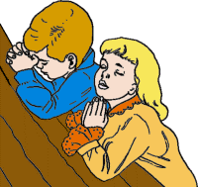**Prayer:** Let’s pray that God will come into this room and touch our hearts today. I love you, Jesus!

**Song and Offering:** “Read Your Bible, Pray Every day” It’s the best way to make sure that Jesus stays our friend.

**Craft: Make Your Own Butter**

½ pint of heavy cream

1 clean pint jar or other similarly-sized container with a tight cover or lid, preferably plastic

1 clean marble

Directions: Take your jar and place the marble inside. Pour the heavy cream into the jar and screw the cover on tightly. Shake, shake, shake…Have the children shake the jar. A figure-eight motion seems to work best, but let them shake at will though not so crazy if the jar is glass. If you have a plastic container with a tight lid, you can even roll it back and forth. Listen for the marble bouncing up and down. After the marble cannot be heard anymore, you’ll know the cream is thickening. Keep shaking, and you will soon start to see the glob of butter form. Shake, shake, and keep shaking…

**Memory Verse:** Write the verse on the dry erase board.Shake your butter with me as we say the verse. Then Peter…*shake, shake, shake*, said unto them…*shake, shake, shake*, Repent…*shake, shake, shake* and be baptized…*shake, shake, shake*… etc. Make the breaks however feels comfortable for you.

**Lesson:** Betsy was the new milk cow for John, the innkeeper. She used to live out in the country far from the city of Bethlehem but her owner had died and his widow had sold Betsy to cover some moving costs.

Bethlehem was getting flooded with people and Betsy was nervous. When she got nervous, she produced less and less milk. John, her new owner, relied on Betsy to provide enough milk to make cheese and butter to serve to his guests at the inn. John’s wife relied on the milk to keep her children satisfied. So, John moved Betsy to the stable and gave her the run of the place. She had her own stall, plenty of oats, and best of all…it was quiet.

After a week or so of having the barn to herself, Betsy was producing like never before. The bucket would get so full that John’s wife went and bought another. John was very pleased with Betsy. Betsy was happy though she was getting a little lonely. One night, John’s wife came rushing into the barn very upset. She started grabbing parts of Betsy’s bed and started piling it in the middle of the room. Then she ran out and came back with fresh clean hay and piled it on top of the mound she had made. Betsy was excited to see the new hay! She loved to roll in new hay and loved the way it smelled…sniff…so fresh! As Betsy was heading over to try out the new mound that John’s wife had made, John came in and shooed her off. “Stay away from that hay, Betsy. We have a lady here who is about to be a momma and she needs that bed!” Just then, a thin young man, barely even a man…more like a boy man came carrying a very round young woman in the barn and laid her in the bed of hay. It wasn’t long after that, the young lady was holding a fresh baby boy.

Betsy was drawn to the baby. She didn’t know why. She had delivered a few calves before but there was just something about this baby. There were several other visitors to see the new baby and the very happy red faced mother but Betsy just knew she had to get closer to the little figure. As the new mom and dad fell asleep, Betsy went to her feed box though John called it a manger and looked at the little bundle. He was so small. Betsy nuzzled his little face and the baby woke and saw Betsy. He didn’t cry to see the large animal standing over him. Instead the baby waved his tiny hands at Betsy. “OOOOOHHH,” said Betsy. She knew him. It was as he spoke to her mind. This was her maker. He was tiny. He was just a baby but Betsy knew him as Father. Betsy watched over him for the rest of the night.

***Teacher:*** The thought that the cow could feel and think is kind of silly but it is true. Animals can sense emotions and feel tensions in the air. This cow felt peace because bible prophesy was being fulfilled. Isaiah 9:6 says, “For unto us a child is born, unto us a son is given: and the government shall be upon his shoulder: and his name shall be called Wonderful, Counselor, The mighty God, The everlasting Father, The Prince of Peace.” It was a special birth! The fact that the Lord came as a little baby and then suffered all the growing pains of growing boy. Pimples and scraped knees. He lived life as his creation and then died on the cross to save the people he loved. We honor the birth of our God, Jesus.

**Extended Time Activity:** Cow Masks: pass out the paper plates and the black construction paper squares or crayons to make the spots of the cow. Use a crayon and draw eyes on the cow. Cut ovals out of the pink construction paper and draw a smiley face on it with a crayon. This will be glued towards the bottom of the plate for a nose. Cut the ears out of the black construction paper and glue to the top of the plate. Cut out the eye holes out of the plate and tape the craft stick to the back of the plate at the bottom. While holding the craft stick, you should have a cow mask to tell the story later!



**Down on the Farm**

**Lesson Three: There’s a Snake in the Garden**

**Lesson at a Glance**

**Pre-session:** Tablecloth, play doh, and candy prize

**Song and Offering:** Offering plate or tin

**Craft:** 3 tablespoons liquid dish soap, 1 ¼ cup distilled water, 1 tablespoon of glycerin, empty water bottles for each child, rubber bands and flannel material cut into circles enough for each child

**Memory Verse:** 2-4 poster boards with verse written on them and then cut into puzzle pieces, prize candy

**Lesson:** Rubber snake, note cards with the scriptures written on them, red apple, pink apple, and green apple

**Down on the Farm**

**Lesson Three**

**There’s a Snake in the Garden**

**Scripture Reference: Genesis 3**

**Memory Verse: John 8:44 -** Ye are of [your] father the devil, and the lusts of your father ye will do. He was a murderer from the beginning, and abode not in the truth, because there is no truth in him. When he speaketh a lie, he speaketh of his own: for he is a liar, and the father of it.

**Welcome:** Greet each child with a big smile and a “Howdy-Do!” You could also say, “Sssssssso glad to sssssssssee you!”

**Pre-session:** Cover the table with a table cloth and hand out the playdoh. Encourage each child to create an animal of their choice. Do not tell the children to make snakes, but give each child who makes a snake a candy treat. (Haribo makes gummy sweet and sour treats called Twin Snakes.) Observe how fast the other children catch on to what you are doing. ☺

**Prayer:** Today we are going to pray that God will not let any untruths be spoken in this place. We want to hear the TRUTH of God’s Word.

**Song and Offering:** “Read Your Bible, Pray Every day” It’s the best way to make sure that Jesus stays our friend.

**Craft:** Bubble Snakes

*Night before class*: Mix 3 tablespoons of liquid dish soap with 1 1/4 cups of water (distilled water gives the best results) and add 1 tablespoon of glycerin (found in the baking section at the supermarket). This mix is best left overnight to settle before using.

*During class time:* Place your bubble mix into a shallow bowl or plate with only a small dash of food coloring. Give each child a water bottle with the bottom ¼ cut off. Give each child a flannel cloth or rag-like material cut into a circle and have them rubber band it to the bottom of the water bottle. The children should then take all materials outside. Once they are outside, encourage the children to dip the material into the bubble mixture and gently blow on the spout. A bubble snake should emerge! Take lots of pictures!

**Memory Verse:** This is a tougher verse so today we are going to break into small groups and complete a puzzle. After the children complete the puzzle, have them shuffle the puzzle and move to another puzzle. Every group should start a new puzzle during this round. Each group who completes the second puzzle and can quote the verse together will win prize candy.

**Lesson:** *(The rubber snake tells the story.)* The snake is sitting in the forbidden tree- The Tree of the Knowledge of Good and Evil. You know, it’s too quiet in this garden. I need to see some action…some drama…something! Surely there is something here entertaining. God made this garden. For them. SSSSSSSSSSSSSS…. Why doesn’t God make me a garden?! He is supposed to be love and if he really loved me… Bah! I tried to have a few friends who liked me, who looked up to me the way everyone else looks up to …God… but would He let me? SSSSSSSS… of course not! So, now I’m in this garden He made for someone else.

Now, here comes that ridiculous creature they are calling a woman. I bet she would be fun to torment. She tends to react funny to things. I’m up in the tree that God put in the garden to save for Himself. I’ve noticed that she keeps looking over here at this tree and ssssssssooooo maybe there will be some fun after all.

Let’s see if I can get her attention. Wooomaaaan…oh Evie… I know you’re looking this way, girl, pay attention! Woman… Up here in the tree! Now, she sees me and is coming this way. Hi Eve! You look nice today, though you are the only one of your kind that I have ever seen, but you are prettier than the prettiest gorilla. I have a question for you. Did God say that you could eat of all the trees in the garden? *(Have a child read Genesis 3:2-3 on the notecard.)* Surely you won’t die- no you will not surely die. God just told you that you would die because He knows that when you eat of this tree you will be able to tell the good from the bad- just like God. It gives you the ability to be like God. Think about it. You won’t have to listen to Adam tell you no. You will know it all for yourself. Come on, girl, you know you want it. You eat red ones (hold up red apple and put it in the basket), and I’ve seen you munch on this pink one (hold up pink apple and put it in the basket) and this is the same kind…it’s just green. (Hold up green apple and put it in the basket.) Yes, Eve took a bite of the green apple. Ha! I told her it would taste good… a little tart and maybe a little sour. YESSSSSSS! I got her to disobey God! She is in for it now!

*Teacher:* When the Lord discovered that both Adam and Eve had eaten from the Tree of Knowledge of Good and Evil, the Lord did give them a punishment. What the snake didn’t stop to think about is the consequences that he would face for lying to the woman. He lied and tempted her until she gave in and the Lord gave him a punishment too. *(Have a child read Genesis 3:14-15 from the Amplified Bible.)* The snake is going to have to crawl at the feet of every animal and the humans that God made. He will have to eat the dust off of our feet for his lying tongue. Lying is listed among the seven sins that God hates. I want to please God, don’t you? Let’s pray that God will help us not to tell lies.

**Extended Time Game:** Tell Me a Tale: Have the children sit in a circle. One person starts off the tale with 4 words. The next person adds 4 words. And the next, and so on. Example: Child 1: Once upon a time Child… 2: there lived a great… Child 3: big hairy spider with… Child 4: only four legs. He…Child 5: loved chocolate! And he...and so on. You can't use the same word twice in a row (ex. it was a cold, cold, cold…)

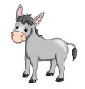

**Down on the Farm**

**Lesson Four: The Talking Donkey**

**Lesson at a Glance**

**Pre-session:** White construction paper, household furniture and household item stickers, and crayons

**Song and Offering:** Offering plate or tin

**Memory Verse:** Poster board

**Lesson:** King’s crown, bible, stick horse, stuffed donkey or horse, white bathrobe, toy sword, and a large stick

**Craft:** See Resource Packet for donkey puppet pattern, glue, scissors, crayons, brown paper lunch sacks

**Down on the Farm**

**Lesson Four: The Talking Donkey**

**Scripture Reference: Numbers 22:9-35**

**Memory Verse: 1 Timothy 6:10** For the love of money is the root of all evil: which while some coveted after, they have erred from the faith, and pierced themselves through with many sorrows.

**Welcome:** Greet each child with a big smile and a “Howdy-Do!”

**Pre-session:** Give each child a white construction paper, stickers of household furniture or household items, and crayons. Have them draw a large house and place everything they can inside of it. If you choose not to use stickers, have them draw beds, furniture, kitchen chairs and tables, etc. When they are relatively done, ask them if they owned this house with all this stuff, could they die happy or would they just want more. Money and “things” are not what make people happy. It’s the love of Jesus! It’s the love you have for others! It is the act of giving!

**Prayer:** Today we are going to thank God for the things that we have and not worry about what we do not have! I’m thankful, Jesus!

**Song and Offering:** “Read Your Bible, Pray Every day” It’s the best way to make sure that Jesus stays our friend.

**Craft:** Donkey Puppets: Give each child a brown paper sack and the donkey pattern from Resource Packet. Let the children color the pattern then cut it out and glue on the brown paper sack. Make sure that they do not glue the flap shut! ☺

**Memory Verse:** Write the verse on the poster board. Have the children repeat it several times until everyone is comfortable with it. Then playGotcha! Quote a verse incorrectly to your children, omitting or changing a key word. Ask them to shout, “Gotcha!” when they catch the mistake. Let the children take turns saying the verse leaving out a word. Then quote the verse accurately together.

**Lesson:** *(Choose children to play King Balak (king’s crown), Balaam (prophet), and an angel (bathrobe). You will be telling the story from the “Donkey’s” point of view so tell the story while holding the stuffed horse or donkey.)*

I was just grazing in my little corral when all of a sudden a group of big, giant horses came galloping up. They threw up so much dust, I had to sneeze…ACHOO! A big man with a crown and armor went to my master and began to speak in their ridiculous language. If they’d just speak donkey, there wouldn’t be such misunderstandings ALL the time. I am a little nosy so I thought I’d sneak up there and listen to what they were jawing about… and see if this new guy would give me a carrot. I just LOVE carrots. The king had just offered my master a new job…hmm… maybe I’ll be getting new hay this winter after all. WOW! Look at all that money…but he put it back in his pocket.

That night just as I was about to lay under Balaam’s window for a short nap, I heard Balaam talking to himself again…Wait…Nope he’s talking to God. God said don’t go curse the people…Master wants the money…God said don’t go curse the people. And after that, I was fast asleep.

The next morning, Balaam had my favorite blanket and was ready to go somewhere. I sure hope that he listened to God last night. Maybe we are just going into town. I smell carrots though so I have got to be a good donkey and get him where he wants to go so I can have one. I just wish he would leave that stick behind.

We plodded along for a while and all of a sudden…I saw an angel! HOLDING A BIG SWORD! Naturally, I wasn’t getting anywhere close to that! Swords make me shiver. We are not going that way so I ran off the road into the fields. Whew! Far away from that sword. That angel looked angry! Disaster diverted. Wham! Wham! Wham! OW! OW! OW! Balaam is hitting me with that stick and trying to turn me onto the path again. Doesn’t he see that angel?!

I’m going back to the road! I am going to eat that stick if he ever puts it down. When I turned back to go to the road, walking by all those wonderful grapes, there is the angry angel with the sword…again! I’ve got to get around that angel. Let’s see how close I can get to vineyard wall. Oops! Forgot Balaam’s foot was there! Wham! Wham! Wham! OW! OW! OW! Balaam, please, did you not see the size of the sword? Ok, we are almost to the road. Cannot go anywhere but forward now because the path to the road is so narrow. OH NO!! The angel is already here! Nope! Can’t make me go any further! I’m sitting right here! Wham! Wham! Wham! OW! OW! That really hurts, Balaam! What have I done to you to make you beat me with that stick three times now?! Then I got the shock of my life… Balaam answered! HE HEARD ME! I’m pretty upset though so I’m glad he can understand donkey talk. He said, “Because you have abused me and didn’t obey me. If I had a sword, I would kill you.” What?! Am I not your donkey? Haven’t I always obeyed you ever since you got me? Balaam answered, “That’s true. Then why…Oooohhhhh!” Finally! Balaam saw the angry angel! I’m so glad! The angel is telling Balaam that he disobeyed God to get more money and the angel would have killed him but I saved his life. Oh good, Balaam is repenting. God is having mercy!

*Teacher:* Just like Balaam, we need to repent. We do not have a donkey to help us avoid the danger, but God has given us a Pastor. Our Pastor teaches God’s word to us and if we obey-we are rewarded but if we do not obey, then we need to repent. Repent means to turn away from sins. Stop doing those things that we know that makes God sad or even angry. We do not want God angry with us. Acts 2:38 says that if we repent of our sins, and be baptized in Jesus Name, our sins will be remitted. They will be washed away to be remembered no more. Then God will give us a gift. Balaam’s donkey was hoping for a carrot but God promised that He would live inside us- the Gift of the Holy Ghost. Let’s talk to the Lord right now.

**Extended Time Game:** Red Rover, Red Rover: Divide the children into two teams and choose a leader for each team. The kids form into two parallel lines opposite each other, and join hands (or join wrists). (*For playing boys and girls, you can give them each an adult sock to hold on to instead of holding hands.)* The leader of one team chooses one player from the opposite team and invites them to play by calling "red rover, red rover, let (child's name) come over!" That player called then runs at the opposing team and tries to hurl himself through the children, breaking the chain. If he fails, he joins that chain, and the turn passes to the other side. The game ends when one team has all but one of the players in their chain.

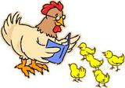

**Down on the Farm**

**Lesson Five: The Hen and Her Chicks**

**Lesson at a Glance**

**Welcome:** Chicken stickers

**Pre-session:** Construction paper, yellow fuzzy pom-pom balls, glue, small wiggly eyes, small orange triangles cut from construction paper, and crayons

**Song and Offering:** Offering plate or tin

**Memory Verse:** Construction paper eggs, tape, two poster boards, and chocolate eggs for prizes

**Lesson:** Library books with pictures of hens and their chicks, quilt

**Craft:** Small paper plates, glue, wiggly eyes, yellow and/or white craft feathers, yellow and orange construction paper, and scissors

**Down on the Farm**

**Lesson Five**

**The Hen and Her Chicks**

**Scripture Reference: Psalm 91:4, Luke 13:34, Matthew 23:37**

**Memory Verse: Psalms 91:4** He shall cover thee with his feathers, and under his wings shalt thou trust: his truth shall be thy shield and buckler.

**Welcome:** Greet each child with a big smile and a “Howdy-Do!” Give each one a chicken sticker.

**Pre-session:** Give each child a construction paper. Encourage them to draw a barn yard. When they feel their yard is complete, help them glue yellow pom-pom balls to the paper. Let them glue on an eye to each pom-pom and small orange triangles for beaks.

**Prayer:** Pray that God will show the children today just how much He really loves them.

**Song and Offering:** “Read Your Bible, Pray Every day” It’s the best way to make sure that Jesus stays our friend.

**Craft:** Chickens!Have the children repeat the memory verse and then hand out small paper plates. Let the children write the verse with a thin tipped marker or pencils. Have them trace their hand on construction paper, cut it out and glue to the back of the plate towards the top where only the fingers will show. Let them glue on feathers to the sides of the plate and the fingers at the top. Glue on wiggly eyes, triangle orange beak, and thin yellow strips of construction for legs.

**Memory Verse**: Cut out several eggs out of construction paper. Write each word of the verse in the egg. (Make 2 sets.) Have the children say the verse several times until they are comfortable with the verse. On two pieces of poster boards, draw two large nests. Separate the class into two teams. The idea of the game is to run to the eggs and pick one, run back to the group and tape the egg in the nest. Once all the eggs have been gathered, the team hurriedly puts the verse in order. The first team finished will be rewarded with chocolate eggs.

**Lesson:** (Pass around the chicken pictures for the children to look at while you talk about the different facts.) Before we start talking about our scriptures, I’d like to share some fun facts about chickens. In Japan, people eat fried chicken and strawberry shortcake on Christmas Eve. A healthy chicken lays about 265 eggs each year. That’s a lot of omelets! Chickens are related to the Tyrannosaurus Rex, they have short wings and large bodies. Chickens will be less nervous if you walk backwards when entering the coop. Most chickens swallow gravel to help mash food. Chickens cluck after they lay an egg. It all sounds kind of silly but here are more facts about chickens and their chicks. Mother hens talk to their chicks when they are still in the egg. Each chicken sound means something specific. Mother hens are so protective of their children that you often cannot see the chicks when you first arrive in the barn. Moms puff up and hide their babies beneath them to ensure that not one single chick is taken from their brood. Even as their children grow, mothers shield them under their wings at night safeguarding them from harm. Chicks cannot get wet and mothers cover them in the rain.

Mother chickens have such incredible maternal instincts that they will even look out for or even take on the children of other mothers when duty calls. There have been cases where multiple mothers are seen walking around with chicks of varying ages and sizes that are clearly not all from the same clutch. They often take them on and nurture them like they would their own children.

Mother hens have also been seen to run at larger predators screeching to draw attention away from their chicks. They will sacrifice themselves to protect their offspring. Mother hens vocalize to their babies as soon as they spot aerial predators too. They've even sounded the alarm on pigeons flying too low over their living area. In response to the mother’s clucking or vocalizing, babies run directly to mother hen for cover.

(Hand out three notecards with the scripture references written on them.) (Have child read Matthew 23:37.) (Have child read Luke 13:34.) Jesus is speaking here to the Pharisees. They had just asked him to leave Jerusalem. He was sad because he had so much to offer them. He wanted to set those bound by devils free. He wanted to heal all that were sick and needing help. Jesus wanted to offer understanding of the scriptures to those who sought it. In plain terms, Jesus was offering the people He loved His life. He loved them so much! He is like that mother hen. Shelters children from the rain and danger, always around (even when they’re grown), showing them the best areas to eat, teaching them His ways. (Fluff out the quilt.) This quilt is like the love of God and the wings of a mother hen. In good times and bad times, there is warmth and love. (Have child read Psalms 91:4.) God wants our love and trust and in return He offers us everything we could ever need. We just need to accept His gift. This gift would be the Holy Ghost. Acts 2:38 says that if we repent and be baptized in Jesus name- we shall receive the GIFT of the Holy Ghost. Pray with the children.

**Extended Time Game:** What time is it Mr. Fox?! (Note: This is a favorite game with my children. The fox is a natural predator of chickens so this was a natural choice.) Choose a child to play “Mr. Fox”. Mr. Fox will stand at the other end of the room. The crazy chicks will stand against the other wall and call out to the fox, “What time is it, Mr. Fox?” Mr. Fox will state a time of his/her choosing… 5 o’clock. The crazy chicks will take 5 steps towards Mr. Fox then call out again. “What time is it Mr. Fox?” This will go on until the chicks are close and Mr. Fox says “Midnight!” Mr. Fox will then chase and tag the chicks. The chicks that are tagged have to stand on the wall with Mr. Fox. The last chick not tagged will become Mr. Fox.



**Down on the Farm**

**Lesson Six: Money in the Mouth? Smells Fishy!**

**Lesson at a Glance**

**Welcome:** Small baggie of gummy worms

**Pre-session:** 2-3 sets of Go Fish Game or make your own

**Song and Offering:** Offering plate or tin

**Memory Verse:** construction paper fish, large metal paper clip, stick fishing pole with a magnet on the end of the string

**Lesson:** Bible

**Craft:** Construction paper, colored cupcake liners, scissors, glue, and a hole punch

**Extended Time Game:** For each team, you will need one set of fishing gear, such as a fishing vest, fishing hat, fishing boots and tackle box.

**Down on the Farm**

**Lesson Six: Money in the Mouth? Smells Fishy!**

**Scripture Reference: Matthew 17:24-27**

**Memory Verse: 1 Samuel 12:24** Only fear the LORD, and serve him in truth with all your heart: for consider how great [things] he hath done for you.

**Welcome:** Greet each child with a big smile and a “Howdy-Do!” Give each one a small baggie of gummy worms.

**Pre-session:** Have at least 2-3 sets of “Go Fish.” Let the children play until you are ready to start for the day.

**Prayer:** Today we are going to pray that God will use us in His kingdom to help someone else.

**Song and Offering:** “Read Your Bible, Pray Every day” It’s the best way to make sure that Jesus stays our friend.

**Craft:** Cupcake Fish- Cut an egg shape out of construction paper. Cut the cupcake liners in half and some in thirds for scales and fins. Use markers to draw the eye of the fish or a googly eye. The mouth is circles from hole punch. Allow the children to create their own fish and encourage them to use their fish to tell their parents the story from today.

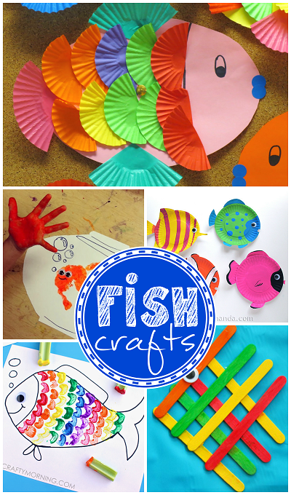

**Memory Verse:** Write each word of the memory verse on the construction paper fish. You should have quite a catch of fish. Line the children up and let them take turns fishing for the verse. Then have them arrange the verse in the correct order. Take turns so everyone has a chance to fish.

**Lesson:** *(Read the lesson from the bible and then tell the story.)*Once there was a fish named Sally that lived in the Sea of Galilee. Sally had a pretty exciting life. Sally always had fun dodging fishermen’s nets, hunting for food and avoiding bigger fish and it kept her very busy. But Sally wanted more. She wanted to do something special for God. Every morning and evening she thanked God for His protection and giving her everything she needed. At the end of each prayer she would always add, “If you ever need me to do anything, I’m ready!”

Sally told all her friends that God was going to use her for something very special. “Sally, God doesn’t need a fish to do anything for Him,” said one. “You’re nothing but a tiny little fish in a sea full of other fish,” said another. “Why would God pick you?” All the fish laughed at Sally. They thought her faith in God was silly. Their teasing didn’t bother Sally. She just smiled sweetly and swam away.

Day after day, her faith grew as she continued to thank God for everything. And as each day passed, she knew that God would use her for something very important. And you know what? He did!

One morning she heard a very soft voice. “Sally... Sally,” said the voice. “Here I am,” said Sally. She looked all around, but there was nobody nearby. “Sally, this is God,” said God. “I need your help.” “What is it?” asked Sally. “Do you know where the old shipwreck is at the bottom of the sea?” asked God. “Yes,” said Sally. “Swim to the wreck. Next to the rudder in the sand is a coin. Go get that coin,” said God.

Sally swam as fast as she could to the old shipwreck. Just as God had said, there was a shiny coin lying next to the rudder. She scooped it up in her mouth and waited patiently for God’s instructions. “Head towards the fishing village on the northwest shore of the sea,” said God. The shipwreck was in the middle of the sea, so Sally swam all morning until she could see the village in the distance.

“In a moment, a small boat will leave. The fisherman will drop a hook into the water. Bite that hook and let him catch you. The coin is for him,” said God. “But…” started Sally. She couldn’t even finish the sentence before God stopped her. “Don’t be afraid. His name is Peter. He will take the coin from you and return you to the sea,” said God. “I will protect you.”

Soon Sally saw a small boat leave the village. She followed the boat until it stopped. Just as God said, Peter dropped a line and a hook into the water. The area was filled with fish and several rushed towards the hook. Sally knew she had to be first, so she charged forward and chased the other fish away. After they left, she grabbed the hook and gave it a good tug. Peter pulled Sally out of the water. He gently opened her mouth. There, sitting in Sally’s mouth was a shiny coin. Peter reached in and removed the coin and the hook.

“It’s here! Praise God, it’s here!” shouted Peter. “Just as Jesus said it would be!” Peter continued to praise God as he lowered Sally back into the water. In a moment, she was free and swimming towards her home.

As she was swimming home, she talked to God about all that had happened. “Who was that man?” asked Sally. “Peter is a friend of mine. Peter told the tax collectors that I would pay the Temple tax. Since I am the one being worshipped in the temple, I would not normally pay the tax. But since Peter said he did, I used you to provide a coin to pay the tax for both Peter and myself,” explained God. “How did he know how to get the coin?” asked Sally. “That was easy. I simply told Peter to go fishing and that there would be a coin in the mouth of the first fish he caught,” said God. Sally thought about it. “But why me?” she asked. “You wanted to do something for me, didn’t you?” asked God. “Yes sir,” said Sally.

“Who do you think gave you that desire in the first place?” asked God. “You must have,” said Sally. “You believed I would do what you asked, so I had to send you,” said God.

Sally kept swimming. There was just one more question she had to ask.

“But of all the fish in the sea, surely there were others that had the same dream. Why me?” “All the others were too busy. You were the only one who would listen,” said God. “And because of this, your story will be told throughout history. People around the world will know all that you did.” “That’s awesome!” said Sally. “Thank you, God!”

From then on, every morning and evening Sally praised God for giving her everything she needed and His protection. At the end of each prayer she would always add, “If you need me to do anything, I’m always ready.”

Teacher: God will use you just like He did this little fish. You do not have to be the biggest, strongest, most talented, best talker, or any “bests” that you can think of- you just need to have a willingness to be used of God. He loves you very much and gave His life for you. Will you give your life to God? To do that just follow Acts 2:38 and repent of all the sin that might keep you from getting close to God. Talk to your Pastor about being baptized in Jesus Name and God has a special gift for you- the Holy Ghost. Bow your heads and let us talk to Jesus right now.

**Extended Time Game:** Fisherman Relay Race: For this game, the children are in two teams. Set the items in a pile on one side of the play space and have the teams line their members up on the other side. When the race starts, the first players in line for each team must run to the gear, put on all of the clothing, pick up the tackle boxes, and race back to their teams. They must then take the gear off and pass it to the next player, who has to put it on and race back to where the gear was originally piled, take it off and leave it all there so that the next player in line can take a turn. The first team that completes the task of having everyone wear and run with the fishing gear wins.



**Down on the Farm**

**Lesson Seven: The Pig Pen**

**Lesson at a Glance**

**Pre-session:** Craft sticks, red construction paper, barn yard animal stickers, glue, and markers

**Song and Offering:** Offering plate or tin

**Craft:** Pudding Cups, Oreos, spoons, small paper or plastic plates, plastic sandwich bags, gummy worms (optional)

**Memory Verse:** Pig Pattern from Resource Packet

**Lesson:** Stuffed animal pig, small papers for drawing

**Extended Time Game:** 2 hoola hoops, 20-30 pink balloons blown up and tied off, and a fly swatter for each child

**Down on the Farm**

**Lesson Seven: The Pig Pen**

**Scripture Reference: Luke 15:11-32**

**Memory Verse: 1 John 1:9** If we confess our sins, he is faithful and just to forgive us [our] sins, and to cleanse us from all unrighteousness.

**Welcome:** Greet each child with a big smile and a “Howdy-Do!”

**Pre-session:** Give each child a red piece of construction paper and a handful of craft sticks. Help the children construct a barn with the craft sticks and glue to the paper. Hand out a sheet of barn animal stickers to put in and around their barn.

**Prayer:** Encourage the children to love the Lord and thank Him for the opportunity to come into His house today.

**Song and Offering:** “Read Your Bible, Pray Every day” It’s the best way to make sure that Jesus stays our friend.

**Craft:** Mud Pies: Pass out the paper plates, pudding cups, spoons, and sandwich bags. Hand out 2 Oreos to be put into the sandwich bag, sealed, then crushed. Scoop out the pudding into the plate with the spoon. Sprinkle the “dirt” over the top. Additional toppings can be chocolate chips for rocks and gummy worms.

**Memory Verse:** Pigs in a Row- Bring out the first pig with the first 2 words on it. Tape to the dry erase board. Have the children repeat the first 2 words and say them aloud. Next, tape the second group of words up on the dry erase board. Have the children read the words on the first pig and then add the words on the second pig. Let them read the words without pausing. Add the third pig. Start on pig one, then pig two, then pig three. Quote the words all together before adding the next pig. Etc…

**Lesson:** Write each child’s name on a piece of paper then save for later.

Teacher: Hi everyone! Meet Hammy. Hammy has a story to tell to you today.

Hammy: Well, it all started out on a day like today…or maybe it was yesterday…or maybe the day before. Well, that doesn’t matter. I get the days confused but I was wanting to tell you about my friend, Benjamin. Well, not quite my friend. See, he didn’t want to be my friend but I was his friend… you know what I’m saying? How did I know I was his friend? Because he told me EVERYTHING!

See, Benjamin came from a wealthy family…though you wouldn’t know it from the way the rags hung off of him…and he stank… worse than the eggs Master throws out here sometimes. Anyhow, Benjamin told me that he was a fun loving guy and liked to play (just like me) and eat whenever he wanted to (just like me) and do whatever he wanted to do (just like me.) See why we would have been best buddies? We have…HAD so much in common. You want to know what else Benjamin told me?

Benjamin told his daddy that he was through with working sun up to sun down when they had servants who could do that. I mean, his dad could just snap his fingers and someone else would have done all the work. That would leave more play time. His daddy asked him what he wanted him to do and Benjamin said just give me the money you were going to leave me when you die. When I die, I guess my buddy, Pork Chop, could have the corn cob I’ve been saving for a rainy day. Oh well. His daddy gave him the money and so he went looking for someone to hang out. Benjamin had been working for his dad for so long he didn’t have very many friends who weren’t out working themselves so he moved. When he moved to the new town, just about a two hour walk up the road a bit, he just got himself some friends. He started buying people lunch every once in a while…giving some money to a buddy for some new duds (though I never got to see what they looked like) and even got himself a pretty girl. Life was good for old Ben until there was no rain. OOOOOOHHHHHHH I just hate thinking about it. The food that I like to eat, the Master was eating it and I was getting the nasty stuff. That’s when I met Benjamin. He was supposed to feed us but when Master wasn’t looking- Ben was eating some of my food. I would have been mad but Benjamin told such great stories. He really missed his home and his dad. Benjamin wore dirty rags when he came and he told me that his friends just up and left him after all of his fun money was gone. He said that when he went to ask them for a loan, they told him to get lost. He showed me a rat bite that he got while trying to steal a rat’s dinner. I’m a great listener though most people say I’m a ham… not sure what that means. One night as Benjamin was talking about his Cookie at his father’s house and the great meals she could cook, I was slobbering so bad I made a slobber mud pie. It sounded so YUM but all of a sudden, Benjamin jumped up and started yelling. “My Father’s servants have it better than me right not. I’m going home and I’m going to ask my dad if I can just be a servant. At least I won’t have to eat this gross pig food!” Now, I agreed with Ben but still….Really?! Then, Benjamin left to go home. Later, I heard Master telling Bill (the new guy who brings my food) that he had just got a letter from Benjamin. His father had forgiven him and took him not as a servant but as a son. I’m really happy for Ben. Now, that’s my story. Can I have a carrot or celery stick now? Those are my favorite!

Teacher: Just as the son was forgiven after throwing away his inheritance for sin, Jesus will forgive us for sin. We do not want to stay in the filth of sin. If you wear a white shirt and a white skirt or pants into a pig pen- what will happen? It will get dirty. Sin makes you dirty. If you want to change, then the Lord will wash you clean of those sins. Repent of the sins and be baptized in the waters of baptism. When you are clean, the Lord will give you a gift. The gift of the Holy Ghost! Praise the Lord!

Draw the name of the child to win the stuffed pig.

**Extended Time Game:** Pig Corralling: When pigs get hungry, they go crazy for food! Put two hoola hoops at the opposite ends of the room and dump your balloons in the middle of the room. Separate your class into two teams and give each child a fly swatter. When the timer starts everyone has to try to corral as many pigs as possible into their pen (hoola hoop). Let’s try to get as many pigs back in the pen before the timer goes off. The team who has corralled the most pigs wins!

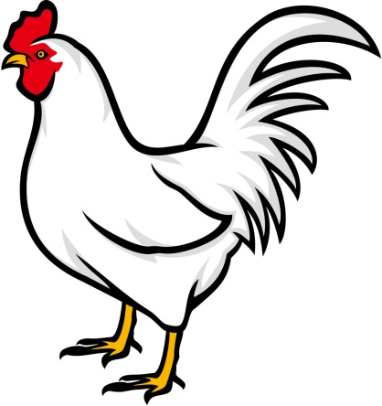

**Down on the Farm**

**Lesson Eight: Cock-A-Doodle-Do! The Rooster Crowed**

**Lesson at a Glance**

**Pre-session:** Rooster pattern from Resource Packet, pencils, red yarn, glue, and multi-colored craft feathers

**Song and Offering:** Offering plate or tin

**Craft:** Per Child: Polystyrene ball, paper cup, brown tempera paint, red paper, orange paper, yellow paper, wiggle eyes, glue, and double sided tape

**Memory Verse:** Red Balloons

**Extended Time Game:** Dry erase board, dry erase marker, and prize candy

**Down on the Farm**

**Lesson Eight: Cock-A-Doodle Do! The Rooster Crowed**

**Scripture Reference: Mark 14:27-31; 66-72**

**Memory Verse: Romans 1:16** For I am not ashamed of the gospel of Christ: for it is the power of God unto salvation to every one that believeth; to the Jew first, and also to the Greek.

**Welcome:** Greet each child with a big smile and a “Howdy-Do!” Or even a Cock-A-Doodle-Do!!

**Pre-session:** Copy a rooster for each child. Let them glue feathers on the tail, googly eye and red yarn for his comb and beard. Have them copy the memory verse on the rooster’s belly.

**Prayer:** Today, we are going to let God know that we are proud to be called His children!

**Song and Offering:** “Read Your Bible, Pray Every day” It’s the best way to make sure that Jesus stays our friend.

**Craft:** Roosters- Glue the ball to the bottom of the cup and paint with brown paint.

Cut tail feathers from red and orange paper and glue to the back of the cup. To make the crown, fold a small piece of paper in half and cut out the crown shape so you have two identical pieces. Glue together along the top edge. Fold out the bottom edges and use double sided tape to attach to the top of the head (will look like praying hands sitting on top of the head).

**Memory Verse:** Put each word of the verse inside of a red balloon. Separate the children into two teams. Dump all of the balloons into the middle of the floor. When you give the signal, have them rush forward, pop the balloon with their feet, and grab the paper from inside. Their individual teams will have to race to put the verse in order. The teams might have to exchange words if they have a duplicate.

**Lesson:** (Read the scripture references from the Amplified Bible.) (Chose a Peter, 3 men and a servant girl. Everyone else can play the rooster.)

*Teacher:* Jesus was arrested for alleged blasphemy and was having a “trial” during the time of our story. Peter has followed the group of people who took Jesus and is even now listening or trying to listen to what is going on. He wants to know what is going to happen to Jesus.

*Peter:* Brrr… it’s a cold night. I wish I could hear what is going to happen to Jesus. I’m going to go over here and see what I can hear.

*Servant Girl:* Hey! Hey You! You’re one of those men that were with Jesus of Nazareth.

*Peter:* Nope! Not me! Ha! Ha! You have mistaken me for someone else.

*ROOSTER:* COCK-A-DOODLE-DO!!!!

*Peter:* Oh no! There’s that rooster that Jesus warned me of. The way that girl looked at me. I might be arrested. I’m just going to move on over here.

*Servant Girl:* You know, George, Bob, and Daniel- this man was one of the men that was with Jesus. See, he even is a Galilean. He talks and acts like one. Look- that guy right there.

*Peter:* Me?! Lady, you have the wrong person! You need to bug someone else.

*George, Bob, and Daniel:* Yep, he’s one of them.

*Peter:* Guys, what are you doing looking at me like that?! I am not one of those stupid, ignorant idiots from Galilee. Who is this Jesus character?! I’m NOT a follower of Jesus! I SWEAR!

*ROOSTER:* COCK-A-DOODLE-DO!!!!

*Peter:* Oh no! Jesus said that I would do this to him. I’m not a good friend or follower of him. I’m so sorry, Jesus. (Crying.) I’m so very sorry! Please forgive me, God.

Teacher: Jesus loved Peter enough to accept his apology. He forgave and forgot. Jesus used Peter on the day of Pentecost. This moment can be found in Acts chapter 2. In Acts 2:38, Peter said to Repent, be baptized in Jesus Name and said that we shall receive the gift of the Holy Ghost. Peter saw what Jesus lived and preached and when it came time to put those examples into words, it was all summed up in this scripture. Do you want forgiveness and acceptance? Let’s pray right now.

**Extended Time Game:** Pictionary: On a dry erase board, let the children draw anything to do with a farm, barnyard, animals, farm house, etc. Let their imaginations run with this fun filled activity. The team who guesses the right answers the most wins prize candy.



**Lesson Nine: The Lost Sheep**

**Lesson at a Glance**

**Pre-session:** Sheep picture from Resource Packet, construction paper, scissors, glue, wiggly eyes, and pencils/pens

**Song and Offering:** Offering plate or tin

**Memory Verse:** 2 poster boards

**Lesson:** Bag full of stuffed animals

**Craft:** 2 Tbsp unsalted butter, 2 2/3 cups mini marshmallows (plus a few additional for assembly), 4 cups multi-grain cheerios or chocolate cheerios (depending on desired sheep’s color), 10 - 12 M &M’s with Almonds, 1/2 cup semi-sweet chocolate chips, 20 - 24 in pretzel sticks

**Extended Time Game:** Tape, blind fold and a blanket

**Down on the Farm**

**Lesson Nine**

**The Lost Sheep**

**Scripture Reference: Luke 15:3-7**

**Memory Verse: Luke 11:9** "So I say to you, ask, and it will be given to you; seek, and you will find; knock, and it will be opened to you

**Welcome:** Greet each child with a big smile and a “Howdy-Do!”

**Pre-session:** Pass out the picture of the sheep. Let the children cut out the sheep and glue it on a piece of construction paper. Pass out the cotton balls and demonstrate how to pull it apart like a cloud and then glue it to the sheep to make a fluffy sheep. Give each child some wiggly eyes for the sheep’s eyes. Encourage them to name their sheep. God has called His children sheep and He knows each one by name!

**Prayer:** Today pray that God will lead us where we need to go and to make us like a sheep…willing to follow His lead.

**Song and Offering:** “Read Your Bible, Pray Every day” It’s the best way to make sure that Jesus stays our friend.

**Craft:** Cheerio Sheep:

1. Place a heavy bottomed saucepan over medium low heat and melt butter. Add marshmallows and stir just until melted.
2. Remove from heat and add 2 cups of Cheerios and mix until the cereal is evenly coated in marshmallow.
3. Spoon out 1 heaping tablespoon of cereal mixture mold into an egg like shape using lightly greased hands. While the mixture is able to be shaped, make an indentation where the head and legs will be placed on the body. (Use an extra almond and pretzel to make the exact size indentation that will be needed, noting that about half of the almond and half the length of the pretzel will need to be embedded into the body for them to remain in place after they have been adhered with the melted chocolate.)
4. Melt chocolate chips in the microwave to use as glue. (This should only take a few seconds.)
5. Apply small amount of melted chocolate to the ends of the almonds and pretzels and press them into the indentations that were made in the body. Allow the chocolate to set.
6. For the ears, cut mini marshmallows into small pieces and use melted chocolate to glue them on top of head.
7. For the eyes, dip a toothpick into melted chocolate and add two dots to face.

**Memory Verse:** Today we are going to find the answer to the code. Seek and you shall find. Write the verse in telephone code on one poster board. Example: “76 4 729 86 968, 275, 263 48 9455 23 44836 86 968; 7335, 263 968 9455 3463; 56623, 263 48 9455 23 673633 86 968” On a separate poster board, draw a telephone key pad with the numbers and alphabet.

**Lesson:** Have you ever collected anything? Many people make a hobby out of collecting things. For example, they may collect things such as coins, stamps, baseball cards, dolls, or miniature cars. Some may even collect items from nature like bugs, butterflies, or sea shells. Even adults collect things like antiques, crystal, hunting stuff, guns, purses, etc.

I have a very nice collection of stuffed toys. They come in all shapes and sizes. I have some that move and talk and I have some really small ones that I got in my Happy Meal at McDonalds. Animals are my favorites. Today, I brought some of them to show to you. *(Show the children the stuffed animals, commenting on each as you show it to them.)*

Oh NO! I lost one of my stuffed babies. I know I had it when I got here. Would you help me look for it? *(Lead the children in a search for the lost animal. When it is found, continue the lesson.)* Thank you so much for helping me find my lost baby. Even though I have a very large collection, every one of them is very important to me and I would be very upset if one of them was lost.

Did you know that Jesus taught a lesson to a group of religious leaders one day about lost things? The religious leaders were very upset that Jesus was often seen associating with sinners. He was even sometimes seen eating with them. The religious leaders didn't like that at all and were very critical of Jesus. Jesus told them a story to help them to understand.

"Suppose one of you had a hundred sheep and you lost one of them," Jesus said. "Wouldn't you leave the ninety-nine who were safe, and go and search for the lost sheep? And when you found the lost sheep, wouldn't you joyfully put it on your shoulders and carry it back home? Wouldn't you be so happy that you would tell all of your friends about finding the lost sheep?" I imagine that all of the religious leaders had to agree that they would do just as Jesus had suggested. Then Jesus said to them, "In the same way, there is more rejoicing in heaven over one sinner who repents than over ninety-nine righteous persons who do not need to repent."

Jesus wants no one to be lost. To save the people He loved, Jesus died on the cross. His blood washes all our sins away. How do we get his blood applied to our lives? We turn away from sin and be baptized in Jesus Name. When our hearts are clean then God will be able to save us. When Jesus comes back, only those who have repented, been baptized and have His Spirit inside of them are going to be able to go to Heaven with Him. Is there anyone here who would like to ask God for forgiveness and give your life to Him? Let’s pray right now.

**Extended Time Game:** First you will need to tape off a square on the floor for the sheep pen. Then choose a child to be the shepherd. All the other children will stand inside the square, and pretend to be sheep by moving around continuously and saying, “Baa, baa, baa.” Then place a blindfold on the shepherd. Next, you will choose one of the sheep from inside the square and have them move to another area of the room. Cover them with the blanket. This child is the lost sheep and can say, "Baa, baa, baa," but must stay under the sheet without moving. Then take off the blindfold and let the shepherd guess which child is the lost sheep by looking at the remaining kids (sheep) inside the square. Remember that the sheep inside the square should be constantly moving around and saying, “Baa, baa, baa” to confuse the shepherd. When the shepherd correctly identifies the lost sheep, that child becomes the shepherd. Choose another child to be the lost sheep under the sheet. Continue until everyone has a chance to be the shepherd, or as time permits.



**Down on the Farm**

**Lesson Ten: The White Horse- Jesus Returns!**

**Lesson at a Glance**

**Pre-session:** Butcher paper, tape, crayons and/or markers

**Song and Offering:** Offering plate or tin

**Memory Verse:** Make copies of a horse, craft sticks and tape

**Lesson:** 2 or 3 Bibles for your readers

**Craft:** Foam craft sheets, scissors, hole punch, markers, stickers, yarn or string

**Extended Time Game:** 4 brooms, 4 chairs, and plenty of racing room

**Down on the Farm**

**Lesson Ten**

**The White Horse- Jesus Returns!**

**Scripture Reference: John 14:1-3, Revelation 1:7; 6:14-16; 19:11, Matthew 24:27, 1 Thessalonians 4:16, Isaiah 25:9**

**Memory Verse: Revelation 22:12-13** And, behold, I come quickly; and my reward [is] with me, to give every man according as his work shall be. I am Alpha and Omega, the beginning and the end, the first and the last.

**Welcome:** Greet each child with a big smile and a “Howdy-Do!”

**Pre-session:** Tape butcher paper to your table top and supply crayons and/or markers for the children to draw their own farm. Encourage them to add all the animals that were in the stories that we have been learning about.

**Prayer:** Today we are going to ask God to help us be ready for His coming!

**Song and Offering:** “Read Your Bible, Pray Every day” It’s the best way to make sure that Jesus stays our friend.

**Craft:** Horse Shoe Door Hangers

Cut horse shoes out of the foam sheets. Let the children decorate the horse shoe however they wish with markers and stickers. Make sure their names are on their craft and hole punch at the top of the U to thread the string through.

**Memory Verse:** Draw a large horse on the poster board. Write the memory verse on the horse. Have the children repeat the verse several times. Put a sticky note over one word at a time as the children say the verse. Help them if they cannot remember the missing part of the verse. Pass out the small horses and have the children tape a craft stick to the back.

**Lesson:** Imagine your favorite grandma. Let’s say that she tells the best stories, gives the best hugs, cooks the best cookies, sings the prettiest you’ve ever heard and loves you the best. Now, that favorite grandma is taking a trip far away and said that she is going to get her new home ready for you but she would come to get you as soon as your new place was ready. She gave you some things that she wants you to do before she gets back. Grandma told you that if you complete everything on the list she would bring you a gift when she returned. After what seems like forever, your favorite grandma is back! She brought some friends with her and she is ready for you to come stay with her. As she is about to hand you the keys to the new sports car that she brought you as a gift, she asks you if you had completed the chores or errands that she gave you before she left… Did you do it?

Can we be sure that Jesus is coming back? *(Have a child read John 14:1-3)* Yes. He promised (just like grandma) that He was going to prepare a place for us to live with Him. When Jesus returns, how many people will see Him? *(Have a child read Revelation 1:7.)* Everyone is going to see Jesus when He comes back. How did Jesus compare His return? *(Have a child read Matthew 24:27.)* His return will be very loud as well as visible. *(Have a child read 1 Thessalonians 4:16.)*

When Jesus comes the earth will be shaken, but how will those who are not ready for Christ's return feel? "Then the sky split apart as a scroll when it is rolled up, and every mountain and island was moved out of its place. And the kings of the earth, the great men, the rich men, the commanders, the mighty men, every slave and every free man, hid themselves in the caves and in the rocks of the mountains, and said to the mountains and rocks, 'Fall on us and hide us from the face of Him who sits on the throne and from the wrath of the Lamb!'" Rev. 6:14-16. They are scared because they do not have the Holy Ghost which gives them the reassurance that when Jesus returns that we will be allowed to go with Him. God's saved people are overjoyed to see Him come. "And it will be said in that day, 'Behold, this is our God; we have waited for Him, and He will save us. This is the Lord; we have waited for Him; we will be glad and rejoice in His salvation.'" Isaiah 25:9

What does this story have to do with the farm? Jesus gets to ride a white horse! *(Have a child read Revelation 19:11.)* Further on in this chapter, it says that the man on the white horse is named “Word of God” and we know who that is…JESUS! Jesus is like that favorite grandma. He loved us so much that He died for us on the cross. He suffered a lot of pain and torture just so that when the world comes to an end that we would be free from sin and able to join Him forever and ever. Jesus did not have a great long list of things that we have to do in order to be able to go to the place He had prepared- we just have to follow what the scriptures say. We need to practice Acts 2:38 and receive Jesus into our hearts. Come, everyone pray right now that God will forgive our sins and cleanse our hearts that we might receive the Holy Ghost and be able to join Him in Heaven.

**Extended Time Game:** Broom Stick Horse Races: Separate the class into 4 teams. Have the children pretend the brooms are horses and they will race to the end of the room, circle around the chairs, and race back.

**Down on the Farm**

**Party!**

Having a good time is the most important part of the party. Let the children participate in making the treats if possible.

Snack Ideas:

Pig in a Blanket

Cotton Candy Sheep- Just cotton candy with chocolate chips for eyes

Chicken Nuggets

Ants on a Log

Fish Crackers

Sunflower Seeds

Go outside if weather permits and do some relay races and obstacle courses. Replay any games that the children remember.

Review the memory verses and see how many the children remember. By repetition we are planting the Word.

Resources

